 | THE UNIVERSITY OF BRITISH COLUMBIA  Department of Electrical & Computer Engineering  EECE 355 – Digital Systems and Microcomputers  Assignment 1 – 2015

Overview: For this assignment, we are going to design the system controller for a Blue Ray Disk (BRD) recorder used to record television programs.
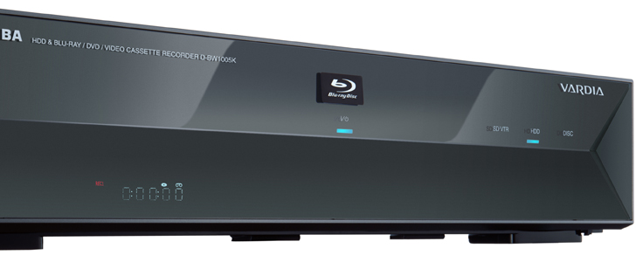

Operation

BRD recorders can be used to record a TV program directly to an optical disk. For the sake of simplicity in this assignment we will ignore the fact that a real BRD actually has a directory structure which allows rapid relocation of the current viewing/recording position on the disk to the start of any program recorded on the disk, and instead think of the disk as just one contiguous spiral of recording media from start to end (a bit like a tape). Multiple programs can thus be recorded back to back on the disk by positioning the current viewing/recording position to the appropriate point on the disk, i.e. search sequentially for it.

Assuming a disk is present in the machine the user could watch a program from it's current (or last played position) by pressing the play button. If a BRD was currently playing and the user pressed the forward or rewind buttons, then a “slow forward” or “slow rewind” operation would take place. Here the BRD would attempt to display the program recorded on the disk forward or backwards at typically 5 times normal playback speed. This mode allowes the user to rapidly relocate their viewing position to another point on the program while semi-watching the program.

However when stopped, pressing the forward or rewind buttons causes the BRD to rapidly relocate to another point on the disk at 100 times normal playback speed to allow the user to rapidly relocate to a new position on the disk perhaps to find the next recorded program (remember for simplicity we don't have a directory structure on the disk to allow us to rapidly locate a new program - unless you feel confident and ambitious!!!)

The forward or rewind buttons have no effect during recording or if no disk is loaded into the BRD recorder. The eject button simply ejected the disk from the machine and it would not do anything further until a disk was re-inserted (physically pushed into the slot – whereby its presence would be detected by a sensor in the BRD).

For the purposes of this assignment, imagine there are two sensors built into the BRD recorder that can sense when we are at the beginning or end of the disk. This could be used to stop the BRD when the end of the disk is reached during playback or recording of a TV program. Similarly when fast forwarding/rewinding

Part A – The Design of the Time Display counter
Design a digital circuit, using VHDL, to keep track of playback record time in the form of HH:MM:SS. This is used when playing/recording/fast forwarding or fast rewinding the disk. The circuit should produce 5 separate four bit digital outputs (1 four bit output for the H, 2 for the MM, 2 for the SS). The time display is to be displayed on the 5 right most 7 segment displays of the DE2. You have already designed a 7 segment decoder and driver as part of a previous lab, so that can be used to convert each 4 bit BCD output into a 7 bit signal for each the 7-segment display. Don’t forget to set up the pin planer for these display (and all other signals)

The circuit should have the following single bit inputs: A 50Mhz Clock, an Increment, a Decrement and a Reset. The increment/decrement inputs should cause the Time display to add or subtract 1 second from the current displayed time on the next rising edge of the clock signal. If neither the increment or decrement inputs are present, the time counter does not change. The time display reset should be synchronous to the clock. This will ensure that any glitches that might occur in the circuit driving the reset have no effect either side of the clock). The increment and decrement signals are all active high signals (i.e. a logic 1), the reset is active low (logic 0).

The signals that will act as the inputs to the time display counter will eventually come from/be generated by a state machine controller and can thus be presented/removed as desired with each pulse of the 50Mhz clock (provided the state machine also changes state at 50Mhz) so there is no chance that increment could be held active for more than 1 clock (as might have been the case if the increment came from say one of the blue/black push buttons for example), i.e. your state machine will enter a state where on one clock of the 50Mhz where it presents, for example, and increment signal to the time display, then, on the next clock, the time display will increment and the state machine will move to a new state where increment is removed, thus te time display is only presented with an increment for 1 pulse of the clock (think about it, it is important).

Your time display should handle full hour, minute and second roll over, e.g. if the display is showing 9:59:59, then the next increment should make it display 10:00:00 and vice versa when decrement is present.

Important: when writing the VHDL for the time display counter, you will have to update the whole time, i.e. HH and MM and SS simultaneously on the same edge of the 50Mhz clock. This is different to how you might have chosen to implement it if you were using a programming language like C, where you might update say the SS value first, then realise it had just roled over to become 00 and subsequently decide to increment MM etc. i.e. you update SS then figure it that you need to update MM.
In VHDL where all things are triggered on the same clock edge, you will have to anticipate the role over by detecting when SS equals 59 (prior to the next clock) and then prepare to add 1 to MM and reset SS back to 00 on the next clock (depends if you use VHDL signals or variables to represent your SS, MM and HH - remember the effect of a change to a signal does not take place until the end of the VHDL process which may mean it would be too late to update MM based on a role over of SS, however changes to variables take place immediately) . Again think about it, it is important. Ditto for decrement.

Test your circuit by connecting it up to the DE2 displays. The inputs can come from switches and push buttons of your choice, e.g. one of the push buttons could be a reset, the other a clock, 2 slider switches could provide the increment or decrement inputs. Remember: reset, increment and decrement are synchronous and only have an effect in conjunction with a clock so you'll have to present your increment signal on a slider switch and the press the push button representing the clock to see the effect.

(30 Marks when fully integrated in the final BRD recorder)

Part B – The Design of the Message Display
Your instructor will give you a zipped Quartus II project which contains the design of a small state machine to drive the 2 line LCD display on the DE2. An explanation of how this works is given in a set of supplementary lecture slides which you can read if you wish, although it is not necessary to understand the implementation to use it in this assignment but it is very instructive.

Open this project, the top level entity will look like this:-

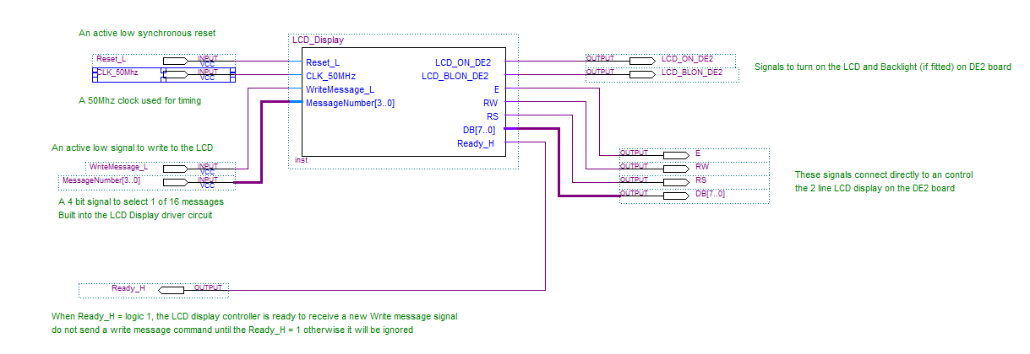

The signals on the right connect directly to the LCD display on the DE2. The signals on the left are used by YOU to control this circuit. It has a 50 MHz clock to derive timing information for the LCD display, plus a Reset. The Ready_H output will be logic 1 when the circuit is ready and able to accept write commands from you (this can actually be ignored). The two other inputs are:-

- WriteMessage_L: Taking this signal Low will, on the next rising edge of the clock, cause the LCD display circuit to begin writing a pre-defined message to the LCD display (this can take several milliseconds to complete - you don't have to do anything while this is happening). If the signal is held low, the message will repeatedly be written to the LCD (although you will not see this) which makes the state transition diagram and implementation of the state machine a little easier since the WriteMessage_L signal can be output while in a particular state (e.g. Moore model) .
- MessageNumber[3..0] : This 4 bit input selects 1 of 16 messages built into the LCD display circuit that can be written to a line on the LCD display. All you have to do is present a 4 bit signal to select a message, then present a logic 0 on WriteMessage_L and the message will be written to the LCD display. The display will remember and continue to display the last message written to it.

Currently this circuit has been wired up in the pin planner so that you can download it directly to the DE2 and try it out. The following pin assignments are relevant:-

Reset_L : Push Button 0 (Key 0)
WriteMessage_L : Push button 1 (Key 1)
MessageNumber[3..0] : Slider Switches 3 – 0
Ready_H : Red LED 0

If you double click on the logic symbol above, you will open up the circuit as shown below, you will see it consists of two blocks each of which are smaller state machines. We don’t need to understand them, we only need to make minor modifications to a 3rd circuit (a read only memory or ROM) concerning the messages that are to be written to the LCD display:-

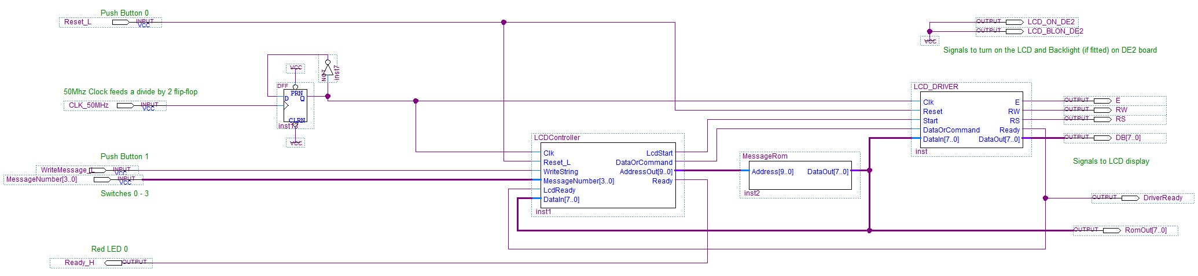

Double click on the MessageRom symbol here to open it up and then scroll down through the VHDL text until you encounter the following code:-

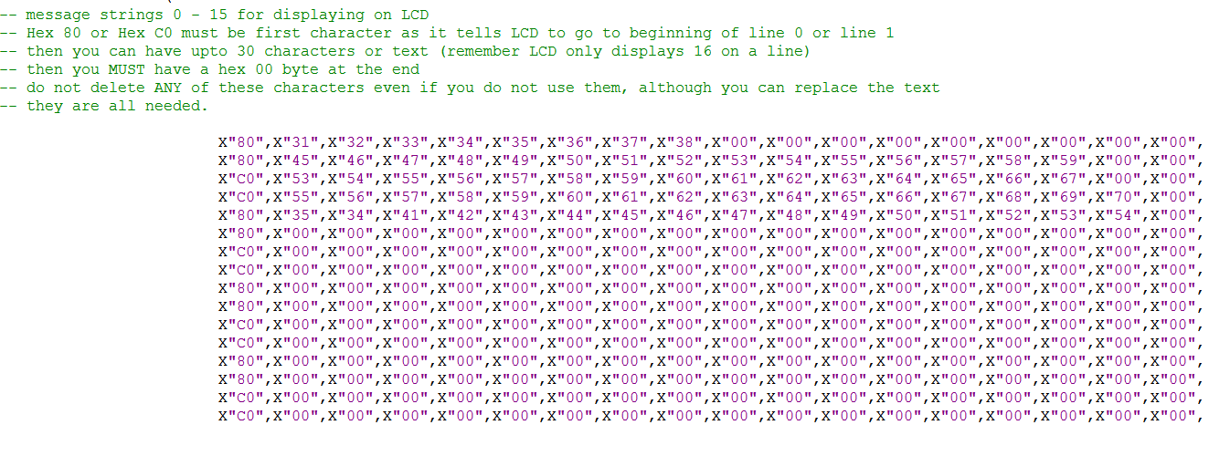
These are the 16 message strings, each of which could be up to 30 characters long that could be written to the display. This is the ONLY part of the code you need to modify. The messages are built up out of individual ASCII encoded bytes, specified in hex, e.g. X”48” (hex 48) corresponds to the letter ‘H’. Check out the ASCII chart from Lecture 3A - Page 18.

The values X”80” or X”C0” at the start of the message are not text, but instead represent a command to be written to the LCD display to instruct it to move to the start of line 0 or line 1 of the LCD display respectively before writing the message. You can change this if required to make your messages appear on one line or the other. The 1st message in the ROM code above is thus the message "12345678" i.e. X"31", X"32", X"33"…. X"38" etc. and will appear on Line 0. Each line of code is terminated by a NULL character X"00" - there must a NULL at the end of each message.

Download the design to the DE2 - the signals have been set up in the pin planner so it should just work, and try setting the switches SW3-0 on the DE2 to the down position and then press Push Button 1. You should message 0 appear on Line 0. Experiment with other switch settings. Note there is an others=>X”00” at the end of the text (not visible above) which is VHDL code to fill any remaining characters in the 30 character string with the value 0 or NULL to indicate the end of the message, do not remove this.

Try changing the messages and recompile/download the code. You’ll have to translate the message characters into hex. We can use this circuit to write messages like “Playing…”, “Recording...”, “Stopped…” etc. in our BRD design.

IMPORTANT : You will have to import the schematic and VHDL files contained in this project into your assignment project (make new ones and then copy/paste content) and create the symbols for the VHDL and schematic (.bdf) files. Before finally connect your circuit to the inputs and outputs for the LCD display driver as appropriate.
(10 Marks when fully integrated in the final BRD recorder)

Part C – The design of a Loadable Timer
To simulate the passage of time (as we are not really controlling a BRD – only a simulation of one), we need something that can measure time. For example we need to measure 1 sec time intervals so that we can control the incrementing of the Time display to simulate realistic playing speed. We also need to simulate 1/5th of a second for “slow” fast forward/rewind (while BRD is playing) and 1/100th second for “very high speed” fast forward/rewind.

In lecture 16 – page 20 onwards we discussed the design of just such a timer based around a loadable counter that counts down under the control of a clock and when it reaches zero it outputs a signal. Using this as a basis for time measurement in our BRD, where necessary, modify the design to include a 2 bit input to select 1 of 3 different values representing 1 Sec, 1/5th Sec and 1/100th sec values that can be loaded into the counter (remember your counter will count at 50MHz.) Make sure your timer only produces a “Done” signal when its value is zero. (i.e. it negate 'Done" after you load it and while it is counting down.) During the simulation of your BRD, this counter can be loaded with a value under the control of the BRD state machine (see below) to simulate the passage of time.
(10 Marks when fully integrated in the final BRD Recorder)

Part D – The Design of the BRD Recorder State Machine
We are now going to design the state machine to control the BRD recorder. This state machine will control the Time Display counter, the loadable timer and the LCD display in response to inputs from the user.

Given the above simple description of the BRD, list all the events/inputs, external as well as internal to the BRD. Internal events include things such as the “Disk present” sensor and the Timer “done” signal. External (user) inputs will include things like a button or switch to simulate the real “eject”, “play”, “stop”, “fast-forward” buttons on a real BRD etc.

Now list all outputs from the state machine, i.e. the things that the state machine is controlling, e.g. timer load plus 2 bit value representing time delay to be loaded, the reset, increment and decrement signals to the Time Display counter, the WriteMessage and MessageNumber to the LCD display.

In essence you will have something like this when you draw the components on a schematic and wire them together:-

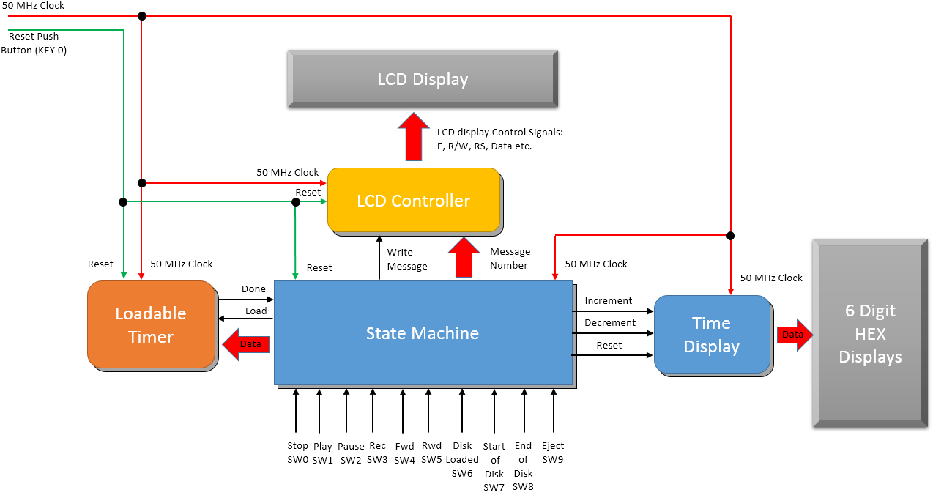

Now consider the operation of the BRD from the point of view of it being in one of a number of states, e.g. stopped, playing, recording, ejected, loaded etc. and thus produce a list of all the possible ‘states’ that a BRD could be in. A different state will be needed every time the BRD takes on new behaviour.

Now think about the following:-
- What inputs, events or conditions are recognised while the BRD is in each particular state?
- What inputs, events or conditions cause a transition to a new state?
- What actions or outputs are associated with each state, i.e what signals do we need to produce or remove in each state ?

Using the Washing Machine example that we looked at in lectures, think about the behaviour of the BRD recorder in the form of a Mealy or a Moore style State Transition Diagram (STD). You can actually use a hybrid of these models (e.g. generate outputs while in a state in response to inputs, i.e. no state transition, and/or generate outputs purely as a function of state) and thus model the event driven behaviour of a BRD recorder in VHDL and download to the DE2 to test/debug. Expect to demo this to the TAs.
Remember, you are only modelling the Disk transport and control mechanism, not the analogue electronics within it that create the picture and sound, consider these as being outside the domain of your digital system.

(20 Marks for a correct, accurate and realistic state transition diagram)
(30 Marks for a fully functioning state machine and BRD simulation on the DE2 board)

Tips:
- DON’T FORGET TO CONNECT YOUR INPUTS AND OUTPUT IN THE PIN PLANNER.
- Present your ‘increment’ or ‘decrement’ to the time display circuit in one state and then transition to a new state immediatly and then remove it in that new state to avoid incrementing/decrementing with every pulse of the (50Mhz) clock.
- The decision about when to present the increment/decrement signals to the time display comes directly from the loadable timer which generates the signal "done" when it has timed out. This "done" signal is shown as an input (event) to your state machine and can trigger a change of state where an increment/decrement and the timer load signal is presented to the Time Display counter and Timer, followed immediately by a transition to a new state where those signals are removed.
- The timer can be programmed with different timeout periods based on the value of the 2 bit signal "Data" above. This signal would be used to select different time periods e.g. 1 sec, 1/5th sec, 1/100th sec etc. based on a 50Mhz clock. The values to actually load into the timer will need to be calculated and hard coded into the VHDL for the timer itself.
- Ignore the "Ready" signal from the LCD display, as long as you present a write message output, the display will continuously write the message to the display (you won't see an flickering because the cursor is turned off). Although it might seem less efficient to keep writing the message continuously, it simplifies our design since we can generate the write message signal as a function of our current state, e.g. when playing, set up the message number to display PLAYING and then assert write message.

Group work
You may work in groups of 2 for this assignment.

Submission
Demonstrations will take place during the Lab (see Connect for deadline). Please have with you all paperwork that you wish to have considered for this assignment. No late or additional submissions will be allowed. Expect to be asked questions on your design and all members of your group must be present to be awarded a mark. The demo date will be posted on Connect

